Solace Connector Designer User Manual

Table of Contents
1. Introduction
1.1. About
1.2. Login
1.3. Checklist Screen
1.4. System Configuration
1.5. Prerequisites
2. Flows
2.1. Create a flow with a Template
2.2. Create a Flow without a template
2.3. Edit
2.4. Delete
2.5. Clone
2.6. Promote
3. Authentication
3.1. Auth Objects
3.2. Create User
4. Designer Guide
4.1. Palette
4.2. Design Area
4.3. Component Configuration
5. Connection Objects
5.1. Database
5.2. Solace
6. Version Management
6.1. Create a New Version
6.2. Read/Edit an existing version
7. System Configuration
7.1. User Management
7.2. Git Configuration
7.3. Environment Configuration
7.4. Upload Connector Binary
8. Connector Management

Introduction

About
    - Solace File Mesh Manager is built to design the Solace connectors and get all the required artifacts to deploy in your respective environments.

Login
    - Access the system using the following credentials:
    - Username: admin
    - Password: admin

Checklist Screen
    - For a fresh installation of CD, after logging in, the checklist screen will be displayed. This screen shows the mandatory configurations required for File mesh manager.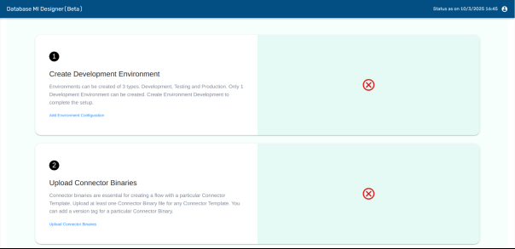
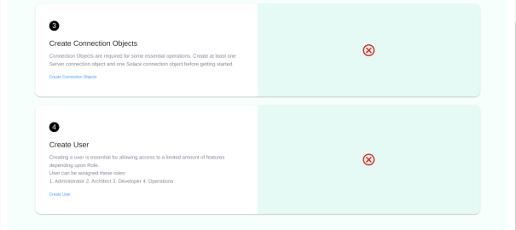
    - Until the initial setup screen is validated, users are restricted from creating flows and deploying connectors.

System Configuration
    - Navigate to the 'System configuration' section and perform the following actions:
    - User Management: Add a new user and assign the appropriate authorization role.
    - Environment Configuration: Create the necessary environments for the application.
    - Upload Connector Binary/Yamls: Upload the connector binary file and default YAML configuration files.

Prerequisites
    - Add a development environment by following the below steps.
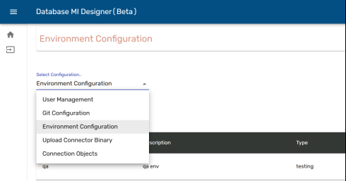
    - Go to the System Configuration screen by clicking on the user profile icon in the bottom left and selecting System Configuration.
    - From the Select Configuration dropdown select Environment Configuration option.
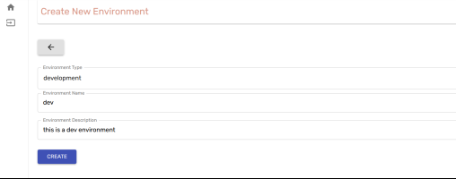
    - Click the ‘Add Env’ button and env form will open.
    - Select Environment Type as 'development' , enter Environment Name and Environment Description(optional) and then click the ‘Create’ button.
    - Now upload a particular connector type's binary files.
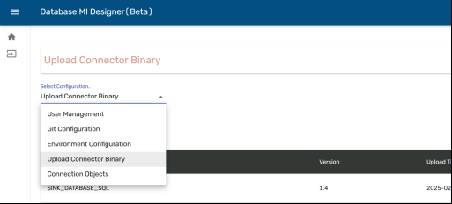
    - Go to the System Configuration screen by clicking on the user profile icon in the bottom left and selecting System Configuration.
    - From the Select Configuration dropdown select Upload Connector Binary option.
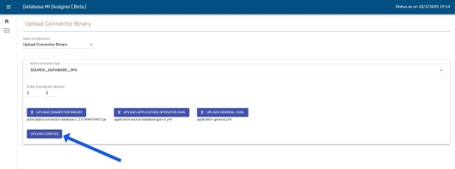
    - Select the Connector Type, enter a version number upload the required files and then click the ‘Upload Configs’ button.

Flows

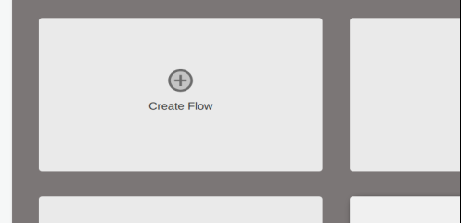
Create a flow with a Template
    - Navigate to the home screen and select ‘Create Flow’, a form will pop up.
    - In the form enter Flow-id, Description.
    - Now select a Connector Template from the dropdown that you want for the flow.
    - Now select the Connector Version below (it will show for all templates except ‘NONE’). These versions are created following the steps mentioned in the above section (3. Upload Connector Binary).
    - The flow version by default is 1.0.0.
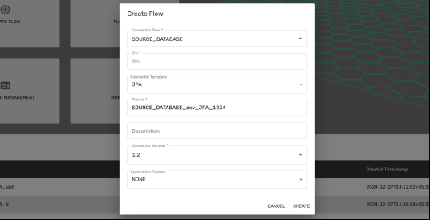
    - Application Domain of choice(optional), then click the ‘Create’ button to create the flow.

Create a Flow without a template
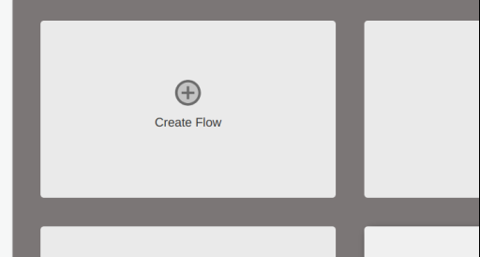
    - Navigate to the home screen and select ‘Create Flow’, a form will pop up.
    - In the form enter Flow-id, Description.
    - Now select ‘None’ in the Connector Template dropdown.
    - The flow version by default is 1.0.0.
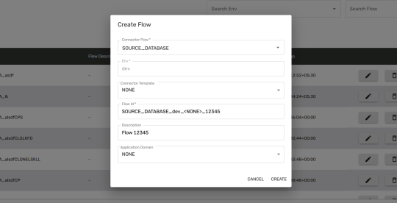
    - Select an Application Domain of choice(optional), then click the ‘Create’ button to create the flow.

    - Source Database_JPA / Source Database_SQL
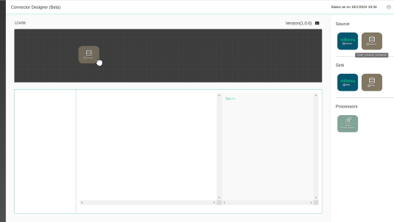
    - Drag Source Database component from the palette and drop it in the design area (grid).
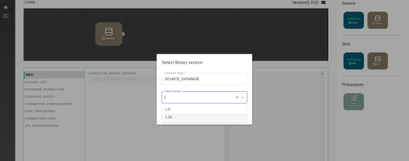
    - After dropping components, a pop-up will open to select the version of the connector binary, select the version of choice and click ‘Okay’.
    - Drag ‘Data Transformation’ and ‘Sink Solace’ components onto the design area.
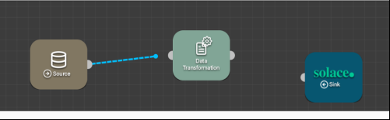
    - Drag the cursor from the connector from either side of one component to another component to connect them.
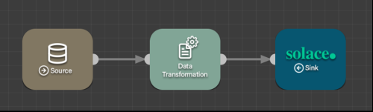
    - Connect them as shown in the figure.
    - Sink Database_JPA / Sink_Database_SQL
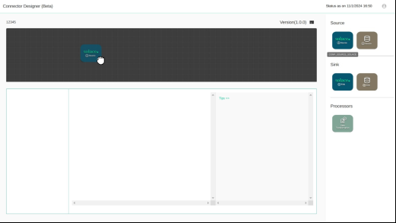
    - Drag Solace sink component from the palette and drop it in the design area (grid).
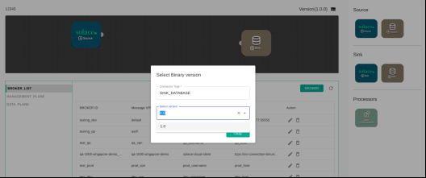
    - After dropping components, a pop-up will open to select the version of the connector binary, select the version of choice and click ‘Okay’.
    - Drag ‘Data Transformation’ and ‘Sink Database components onto the design area.
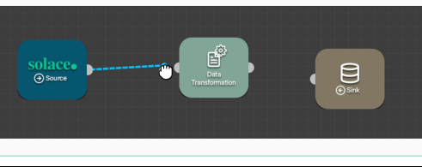
    - Drag the cursor from the connector from either side of one component to another component to connect them.

Edit
    - Click on the ‘Edit Flow’ button (pencil icon) for the flow that you want to edit.
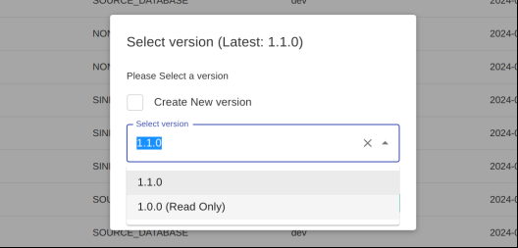
    - A form will pop up, select the version you want to Read/Edit from the Select Version dropdown.
    - Only the latest version is editable, older versions are Read Only.
    - Click Continue to Read/Edit the selected flow version.

Delete
    - Go to the 'Flows' screen.
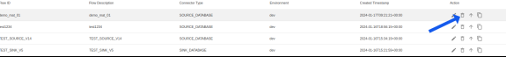
    - Find the table that displays all flows. Each flow has a delete option, which is represented by an icon (as shown in the image).
    - Click on the delete icon. This will bring up a popup with a checkbox 'For deleting a specific version of the selected flow' and two buttons: 'Cancel' and 'Delete' (as shown in the image).
    - If you don't want to delete whole flow, rather just a specific version, check the box which will bring up a dropdown to select version, select the desired version to be deleted.
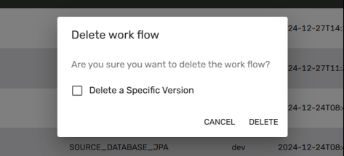
    - To delete the flow or a specific, click on the 'Delete' button. To cancel the operation and close the popup, click on the 'Cancel' button.

Clone
    - Navigate to the Flow-List screen
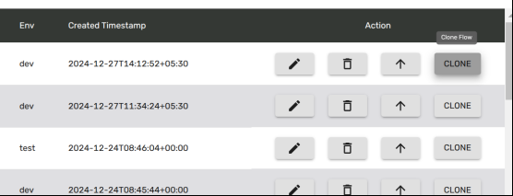
    - From the Flow List table click the ‘CLONE’ button in the action column for the flow that you want to clone.
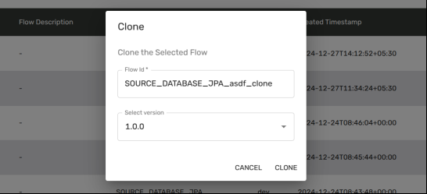
    - A form will pop up, choose a new flow-id for the cloned flow and the version of the flow that you want to clone. If the details are correct then the ‘CLONE’ button will be enabled, click it to clone the flow with the selected details.

Promote
    - Navigate to the Flow-List screen
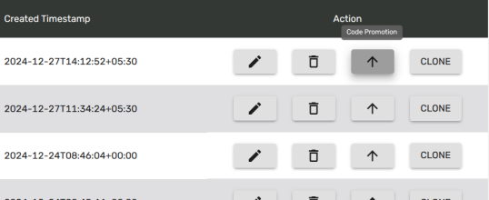
    - From the Flow List table click the ‘Code Promotion’ button(Upwards Arrow icon) in the action column for the flow that you want to do the Code Promotion.
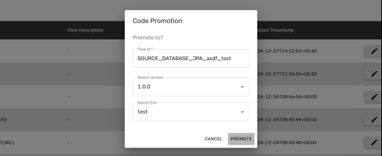
    - A form will pop up, choose a new flow-id for the promoted flow, the version of the flow that you want to promote and the Environment that you want the promoted flow to have.
    - If all the details are properly filled, the ‘PROMOTE’ button will be enabled, click it to promote the flow with a particular Environment.

Authentication

Auth Objects
    - There are three roles a user can have: Administrator, Developer and Read Only.
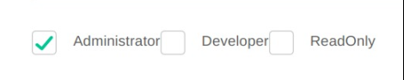
    - The Administrator has access to all the features, like creating/editing flows and accessing System Configuration.
    - The Developer doesn’t have access to the System Configuration but has access to create/edit flows.
    - Read Only user can only view the flow but cannot edit it. Also doesn’t have access to System Configuration.

Create User
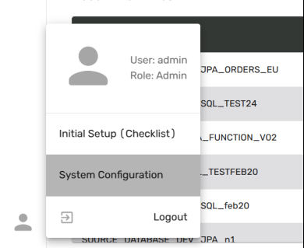
    - Log in to the application with username ‘admin’ and password ‘admin’.
    - Go to the System Configuration screen by clicking on the user profile icon in the bottom left and selecting System Configuration.
    - From the Select Configuration dropdown select the User Management option.
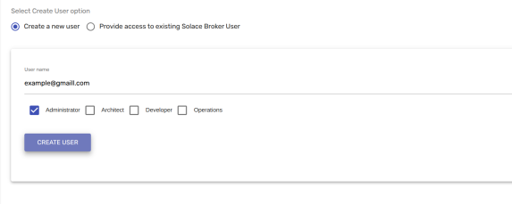
    - Click the ‘Create User’ button, click ‘Create a new user’, enter an email in the username field, select a role and then click the ‘Create User’ button.
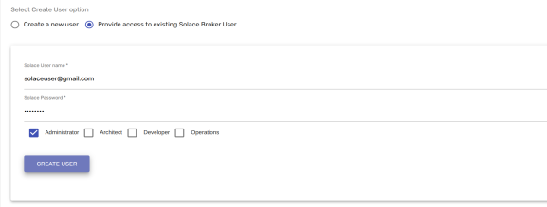
    - To create a user already existing in the Solace broker, select the ‘Provide access to existing Solace Broker User’ option, enter the Solace broker username and the Solace password set for the user, choose the role and click the ‘Create User’ button.

Designer Guide

Palette
    - Go to the designer screen either by create/edit flow.
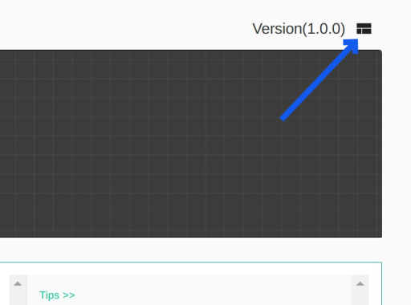
    - Now click on the ‘Open Palette button in the top right of the designer screen, it will open the palette with different components.
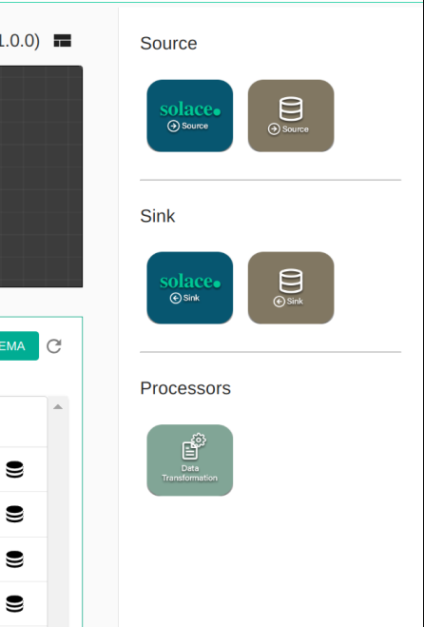

Design Area
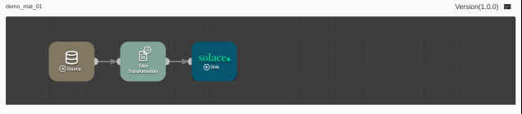
    - The design area is where you can see all the added components.

Component Configuration
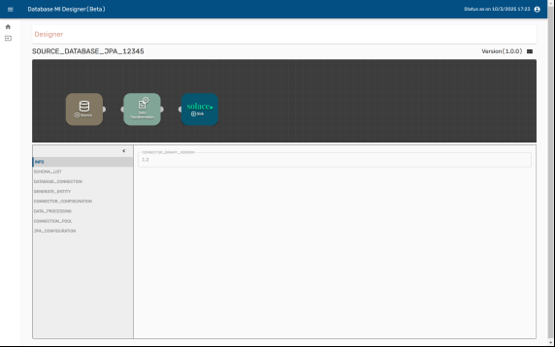
    - The Designer screen will open and components will be Loaded based on the selected Connector Template.
    - On double-clicking any component, details of that component will become visible.
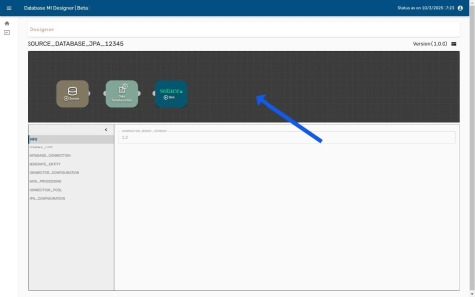
    - On clicking the ‘grid’ background in the designer panel, the General connector details will be loaded in the below panel.

Connection Objects

Database
    - For database connection object, create or edit flow.
    - Click on the database component in the designer area, then go to the 'SCHEMA_LIST' section.
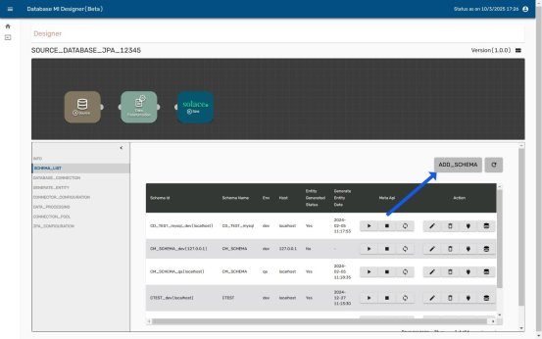
    - Click on the 'ADD_SCHEMA', button as shown in the image.
    - A database schema configuration form will be shown as shown in the below image.
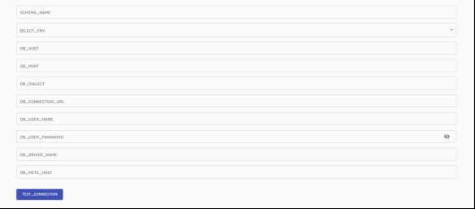
    - Fill out the form and click the 'TEST_CONNECTION' button to test the ￼connection.
    - Once the test connection is successful, click on the 'ADD_SCHEMA' button to add database schema.

- To start the META API for a selected schema, click on the 'Start' button .
- To stop the META API for a selected schema, click on the 'Stop' button .
- The state of the META API can be viewed by clicking on the 'View State' button .
- To edit the schema for a selected schema, click on the 'Edit' button
.
- To delete a schema, click on the 'Delete' icon . A popup will appear with two buttons: 'Cancel' and 'Delete'. Clicking on 'Cancel' will close the popup, and clicking on 'Delete' will delete the schema, including the entity folder.
- To test the connection, click on the 'Test Connection' button .
- To generate an entity, click on the 'Generate Entity' button .

Solace
    - In the designer area, click on the Solace component.
    - Navigate to the 'BROKER_LIST' section.
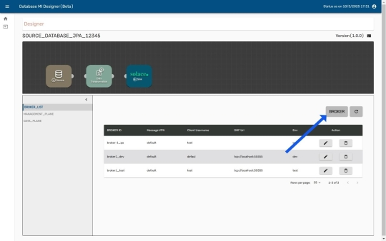
    - Click on the 'BROKER' button (as shown in the image).

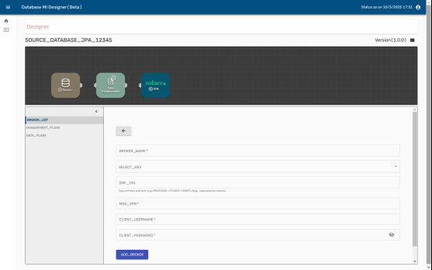
    - A Solace configuration form will be displayed (as shown in the image).
    - Fill in the form and click the 'ADD_BROKER' button to complete the process.
- To edit the solace configuration, click on the 'Edit' button .
- To delete solace configuration, click on the 'Delete' icon . A popup will appear with two buttons: 'Cancel' and 'Delete'. Clicking on 'Cancel' will close the popup, and clicking on 'Delete' will delete the solace configuration.

Version Management

Create a New Version
    - This option is only available for the flow with environment type ‘development’.
    - The flow version by default is 1.0.0.
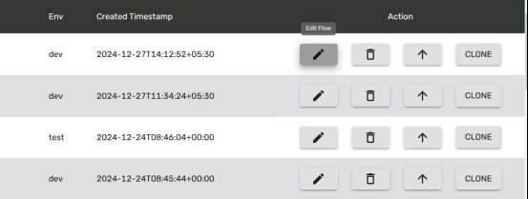
    - Click on the ‘Edit Flow’ button (pencil icon) for the flow that you want to create a new version of.
    - A form will pop up, check the ‘Create New version’ checkbox.
    - Enter a version number, the new version number can be only one more than the latest version.
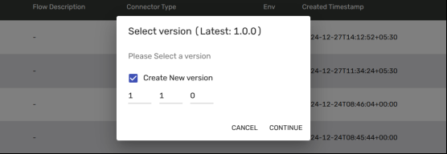
    - The major, minor or patch number must be 1 greater than the latest version. (Version number is a combination of 3 numbers separated by a dot(.). The First number signifies Major, the Second Minor and the Third shows patch.)

Read/Edit an existing version
    - Click on the ‘Edit Flow’ button (pencil icon) for the flow that you want to Read/Edit.
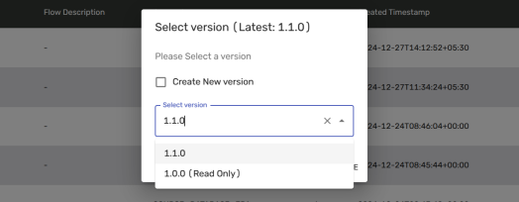
    - A form will pop up, select the version you want to Read/Edit from the Select Version dropdown.
    - Only the latest version is editable, older versions are Read Only.
    - Click Continue to Read/Edit the selected flow version.

System Configuration

User Management
    - Create a new User: Creates a user in solace broker and database
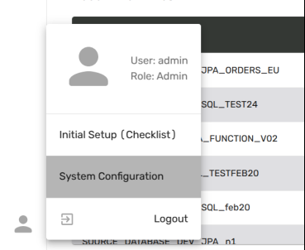
    - Log in to the application with username ‘admin’ and password ‘admin’.
    - Go to the System Configuration screen by clicking on the user profile icon in the bottom left and selecting System Configuration.
    - From the Select Configuration dropdown select the User Management option.

    - Click the ‘Create User’ button, click ‘Create a new user’, enter an email in the username field, select a role and then click the ‘Create User’ button.
    - Change the password for the existing Solace Broker User
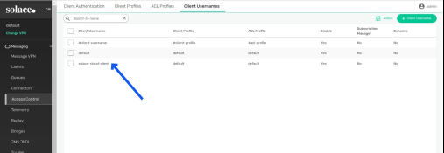
    - Create a password for the Solace user by navigating to the ‘Access Control’ option in the Solace console, then go to the client username and click on the desired user.
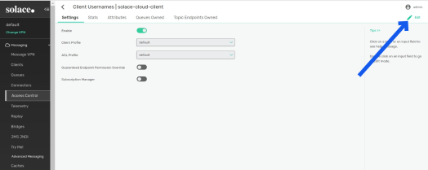
    - Click the Edit button in the top right corner as shown in the image.
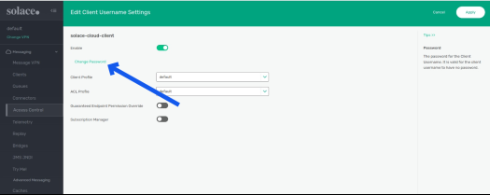
    - Click Change password and create a password.
    - Provide access to existing Solace Broker User: Creates User in the database

    - To create a user already existing in the Solace broker, select the ‘Provide access to existing Solace Broker User’ option, enter the Solace broker username and the Solace password set for the user, choose the role and click the ‘Create User’ button.
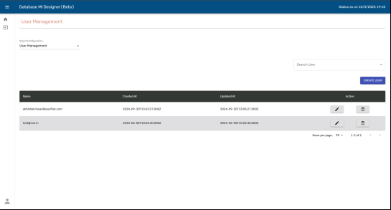
    - To edit a particular user, click on the 'Edit' button for that user.
    - To delete a User, click on the 'Delete' icon . A popup will appear with two buttons: 'Cancel' and 'Delete'. Clicking on 'Cancel' will close the popup, and clicking on 'Delete' will delete the user.

Git Configuration
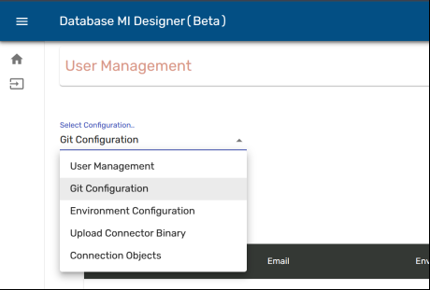
    - Go to the System Configuration screen by clicking on the user profile icon in the bottom left and selecting System Configuration.
    - From the Select Configuration dropdown select the Git Configuration option.
Cloud Git:
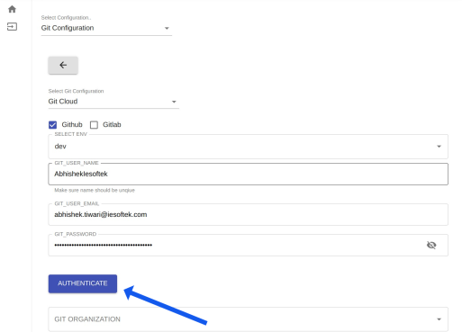
    - Click the ‘Add Git Configuration’ button, select the ‘Git Cloud’ option and the git tool, enter Git Username, Environment Name, Git User-Email, enter Git PAT(Personal Access Token) and then click the ‘Authenticate’ button.
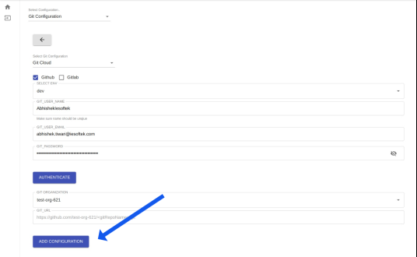
    - After Git details are successfully verified, Git Organizations will be populated in the dropdown below.
    - Select a Git Organization from the list and click the ‘Add Configuration’ button to add the selected Git detail.
Local Git:
    - To use Git on a locally hosted server, the client must first add their SSH public key to the .ssh/authorized_keys file on the remote server where the Git server is hosted. After this, users will be able to add, edit, and configure their Git settings as well as perform Git operations as needed.
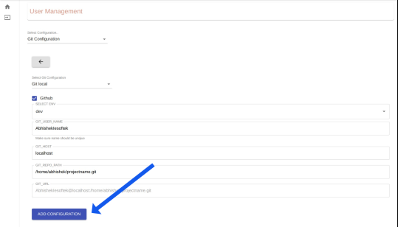
    - Click the ‘Add Git Configuration’ button, select the ‘Git local’ option and Environment name and enter the Git Username, host and repository path on the remote system and click the ‘Add Configuration’ button to add the selected Git detail.
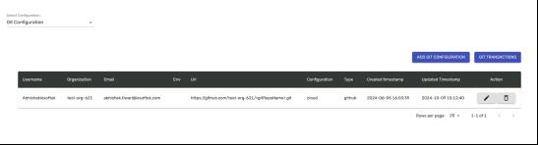
    - To edit a particular Git configuration, click on the 'Edit' button for that user.
    - To delete a Git configuration, click on the 'Delete' icon . A popup will appear with two buttons: 'Cancel' and 'Delete'. Clicking on 'Cancel' will close the popup, and clicking on 'Delete' will delete the Git configuration.

Environment Configuration

    - Go to the System Configuration screen by clicking on the user profile icon in the bottom left and selecting System Configuration.
    - From the Select Configuration dropdown select Environment Configuration option.
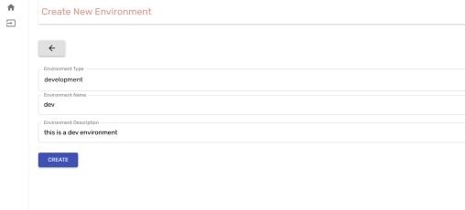
    - Click the ‘Add Env’ button, select Environment Type, Environment Name and Environment Description(optional) and then click the ‘Create’ button.
    - Only a single ‘Development’ Environment can be created.
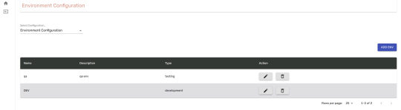
    - To edit a particular Env, click on the 'Edit' button for that Env.
    - To delete an Env, click on the 'Delete' icon . A popup will appear with two buttons: 'Cancel' and 'Delete'. Clicking on 'Cancel' will close the popup, and clicking on 'Delete' will delete the Env.

Upload Connector Binary
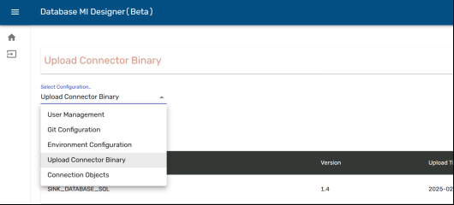
    - Go to the System Configuration screen by clicking on the user profile icon in the bottom left and selecting System Configuration.
    - From the Select Configuration dropdown select Upload Connector Binary option.

    - Select the Connector Type, enter a version number upload the required files and then click the ‘Upload Configs’ button.

Generate Scripts
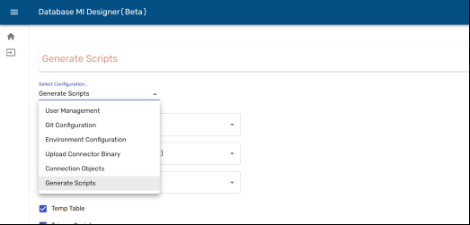
    - Go to the System Configuration screen by clicking on the user profile icon in the bottom left and selecting System Configuration.
    - From the Select Configuration dropdown select Generate Scripts option.
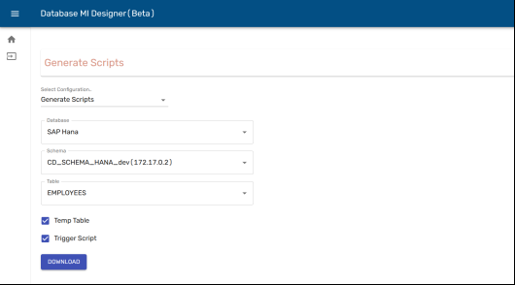
    - Select the Database for which you want to generate the Table and trigger scripts.
    - After selecting the Database, schema names will be loaded in the below dropdown, select the required one.
    - Then select the table for which you want to generate the scripts.
    - Select the script types from the Check boxes (Temp Table, Trigger Script), which you want the downloaded script to have.
    - Click the 'Download' button to download the script with the selected configurations.

Connector Management
    - Log in to the application with username ‘admin’ and password ‘admin’.
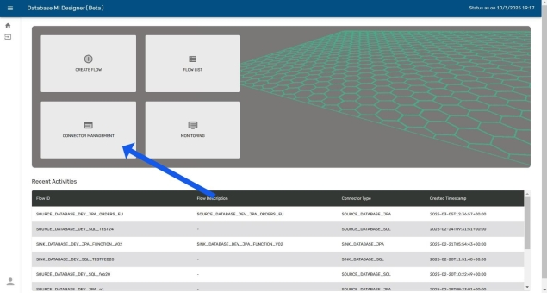
    - Click on the ‘Connector Management’ tile on the homepage to navigate to the Solace Portal.

